Machine Description | The challenge involves service enumeration, credential harvesting, SSH access, and privilege escalation to gain full control of the target system.
Target IP | 192.168.0.109
Vulnerability name | Weak credentials and misconfigured privileges leading to full system compromise.
CVSS Score & Severity | 9.8 Critical
Attack Vector | CVSS:3.0/AV:N/AC:L/PR:N/UI:N/S:U/C:H/I:H/A:H
Proof of Concept | Step 1: The target IP address was identified using the netdiscover tool by scanning the local network range.  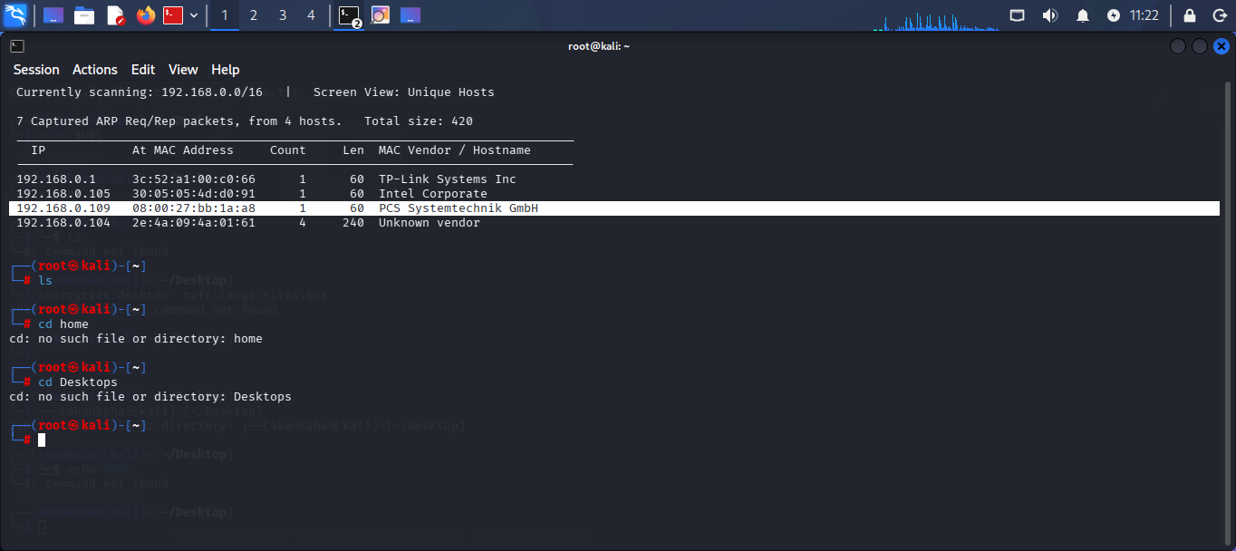  Step 2: The target IP address was stored in a variable for easier reuse in further scanning and exploitation steps.  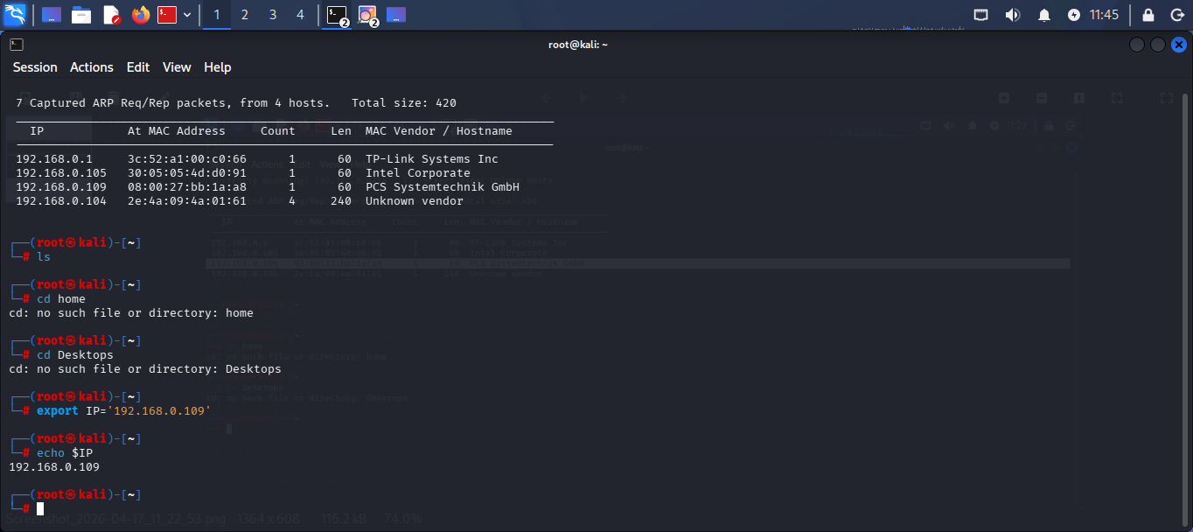  Step 3: Nmap was used to identify open ports and services running on the target system.  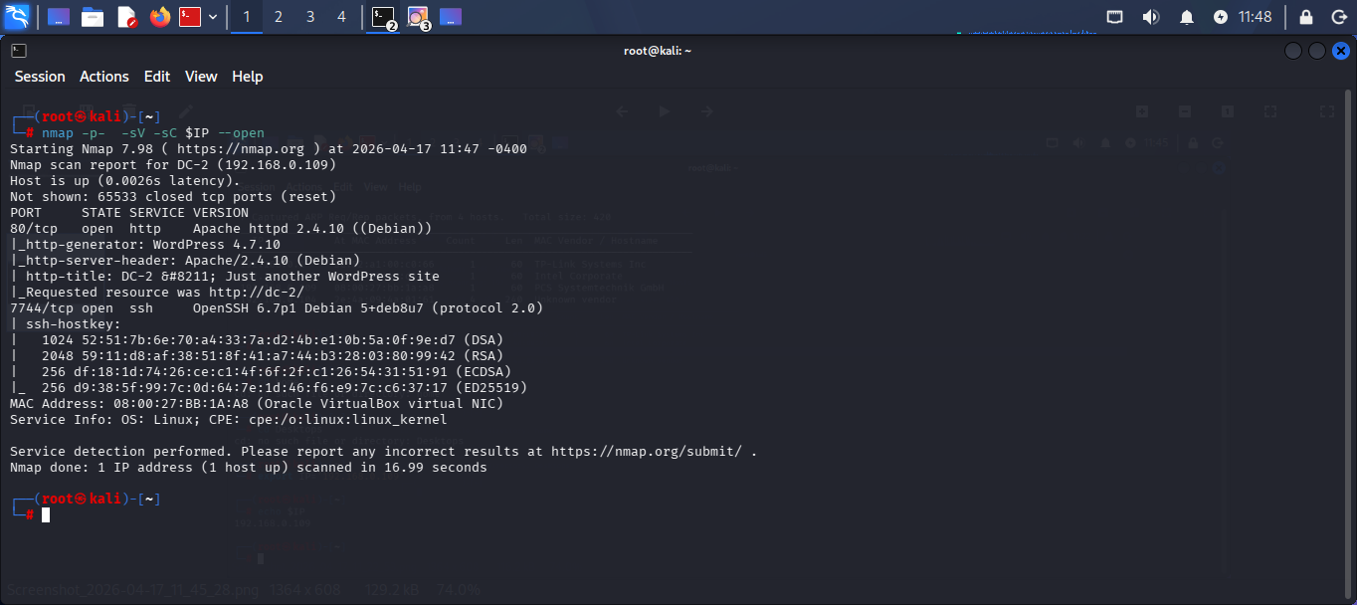  Step 4: The target application was identified as a WordPress CMS, which provided a clear direction for further enumeration and exploitation using WordPress-specific tools.  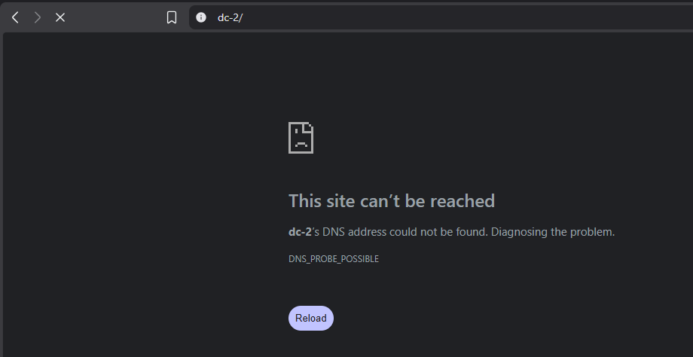  Step 5: The target domain was manually mapped in the /etc/hosts file to resolve access issues.  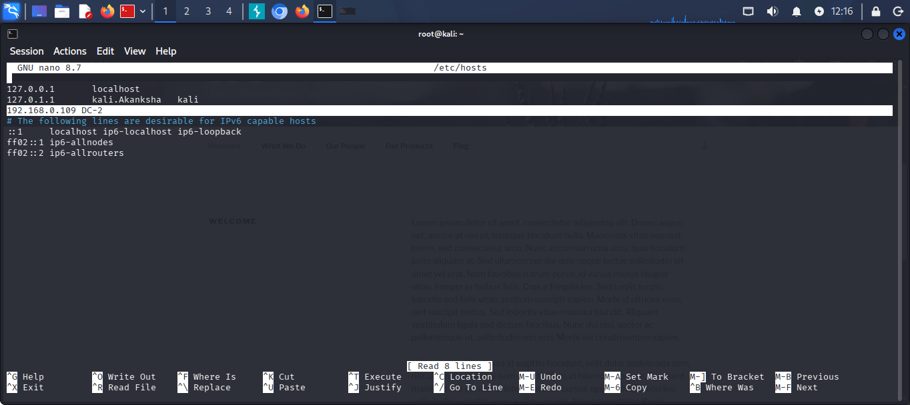  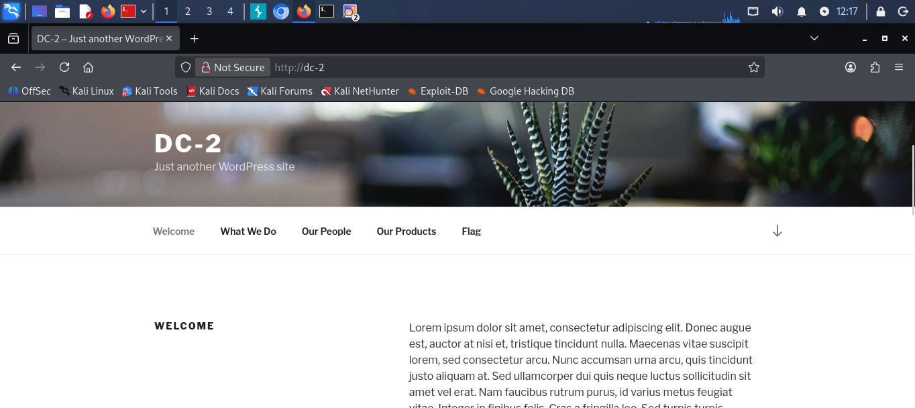  Step 6: WFUZZ was used to identify hidden files and directories, revealing multiple WordPress-related endpoints and confirming the application structure  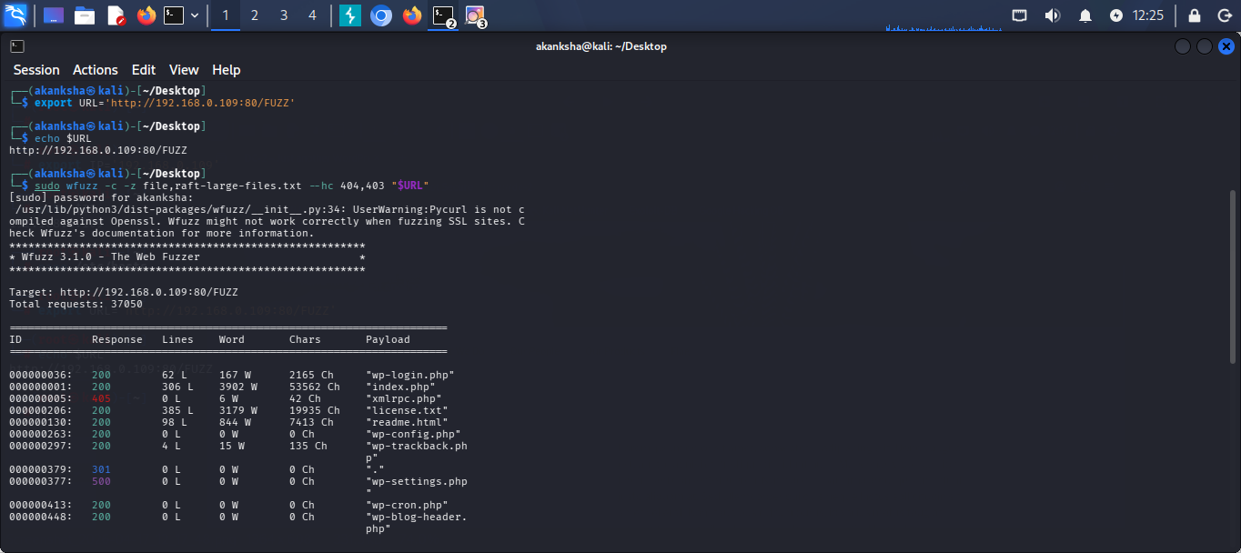  We found wp-login page and lets try to enter test cred and see the behaviour  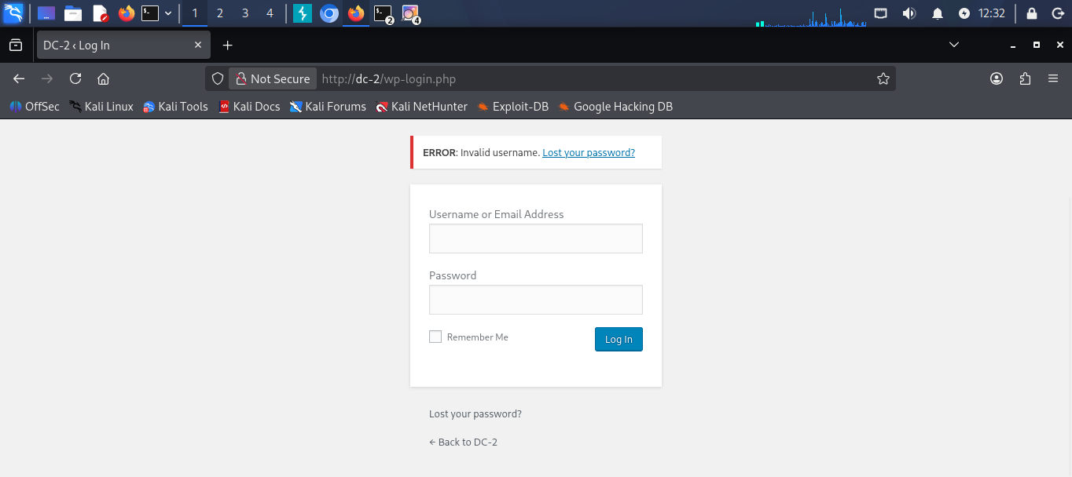  STEP 7 - We found that there is an error that says “Invaild username” so we can try to enumerate valid usernames with this kind of error  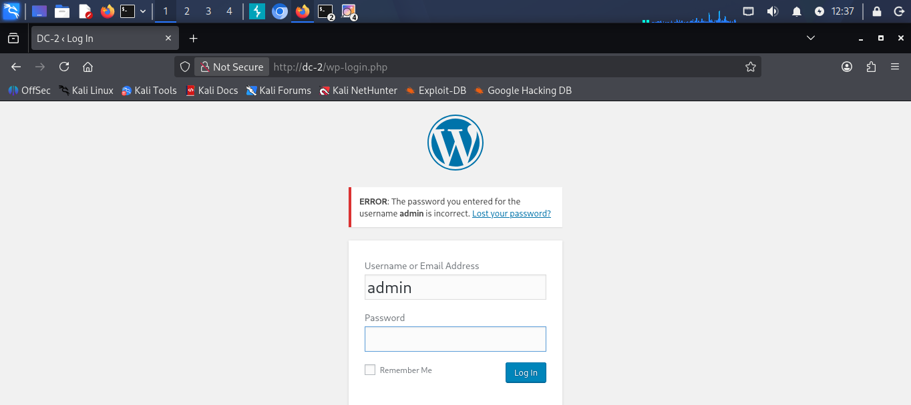  Step 8: WPScan was used to enumerate users, plugins, and themes to identify potential attack vectors in the WordPress application.  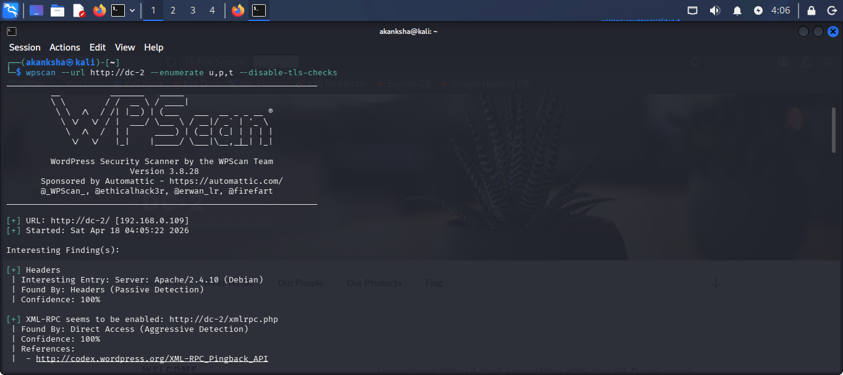  WPScan was used to enumerate WordPress users, successfully identifying valid usernames such as admin, jerry, and tom, which can be used for further brute-force login attacks.  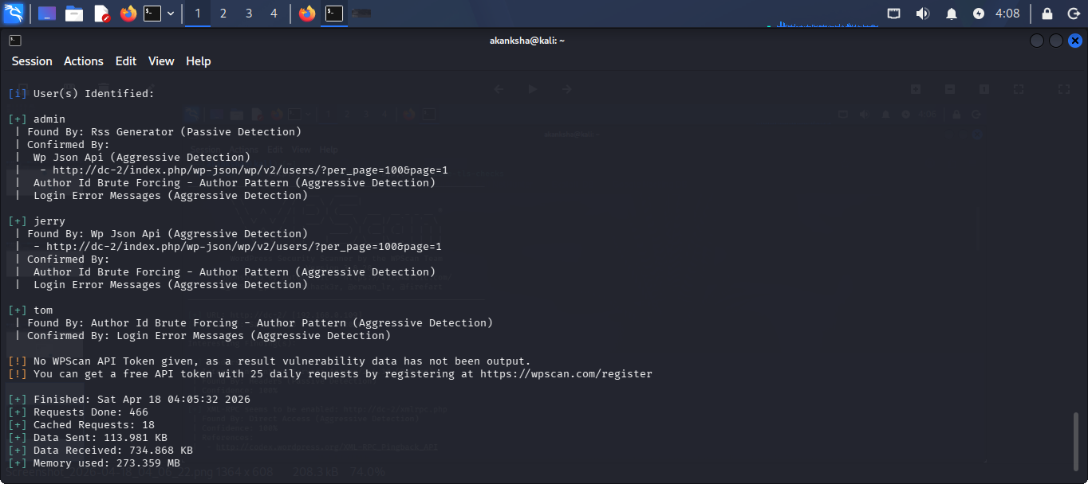  Step 9: CeWL was used to generate a custom password wordlist (pass.txt) from the target website for brute-force attacks.  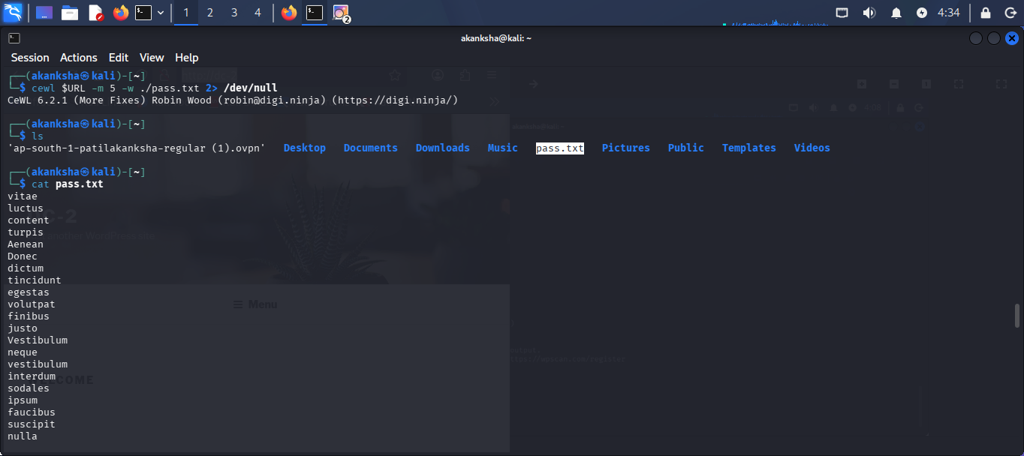  STEP 10 – Brute Force using Wpscan  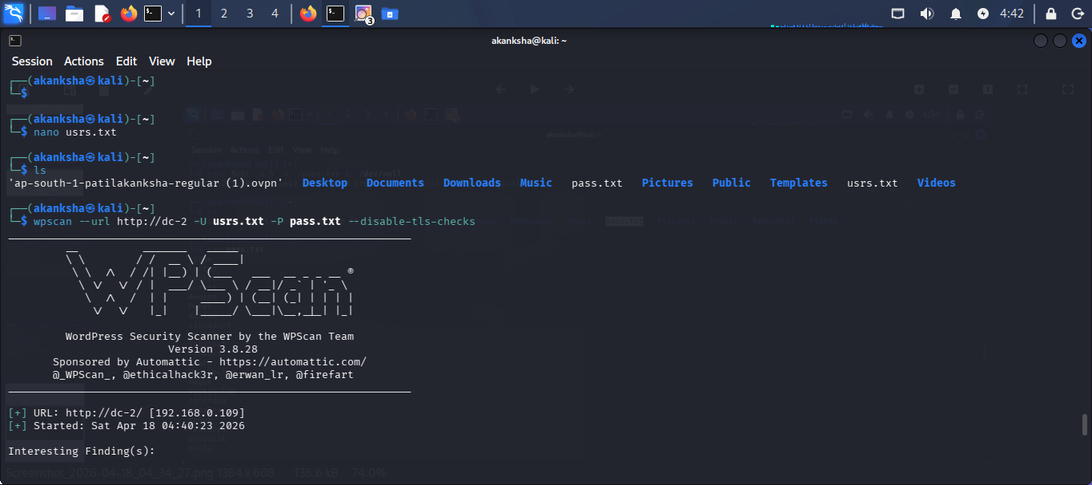  We found Some Valid credentials (jerry: adipiscing) (tom: parturient)  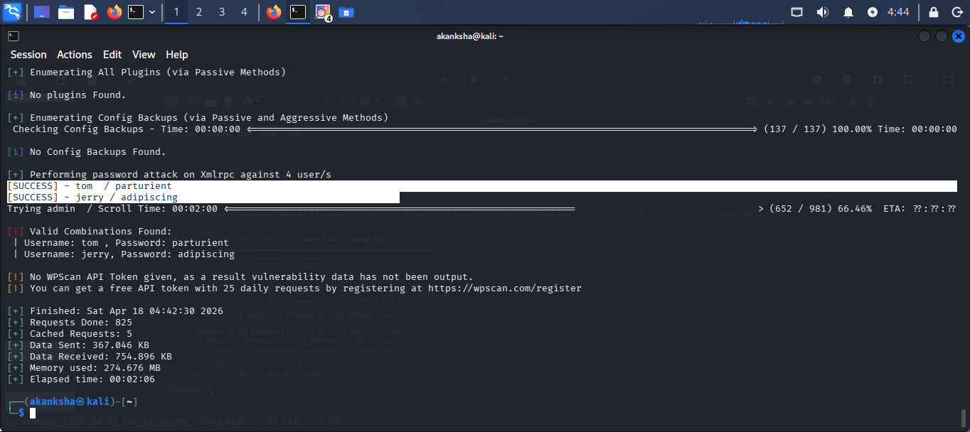  STEP 11 – Let’s attempt to authenticate to the target system via SSH using the discovered credentials.  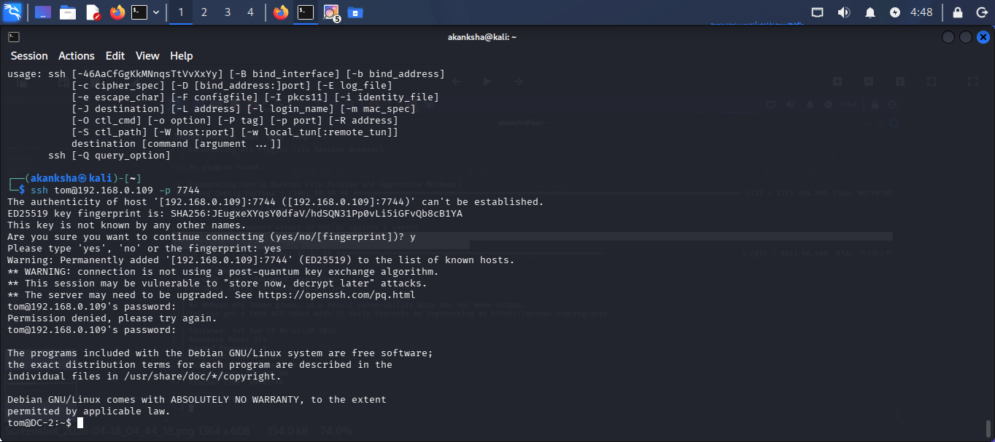  STEP 12 - We got login but we are into restricted bash. Let’s get out of it  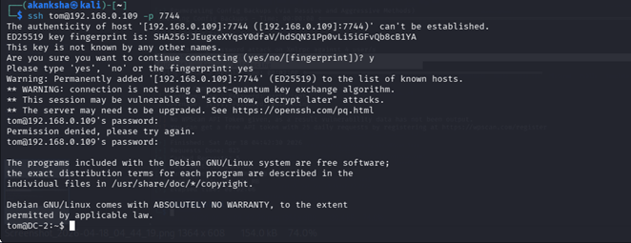  - Open “vi” editor  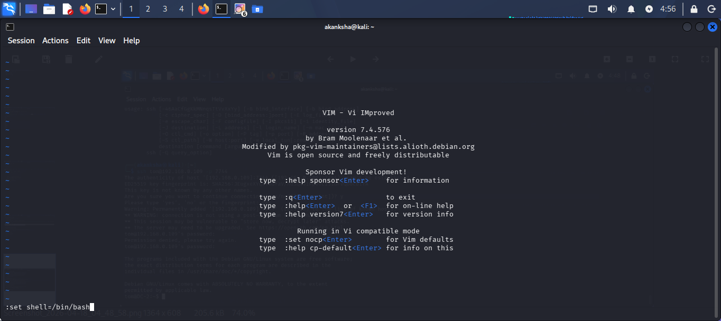  - While we are in command mode lets set variable “:set shell =/bin/bash” and hit enter.    - After hitting Enter we will see that our cursor is again on top and we are still in command mode so next call “:shell” and hit enter  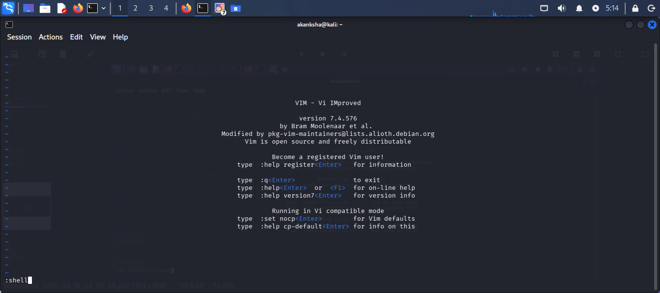  - We will be out of Vi editor and also rbash  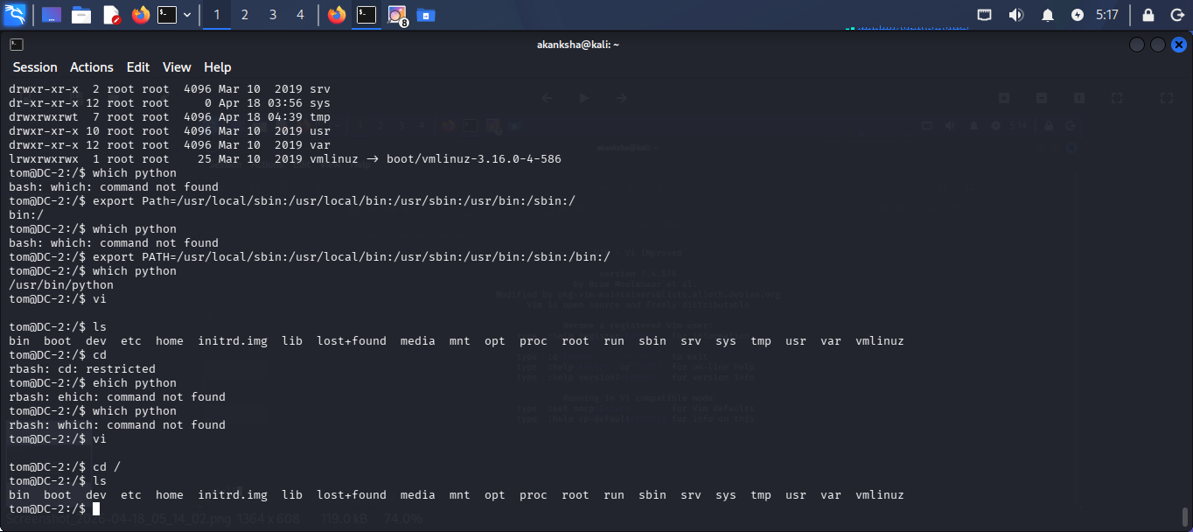  - Our current shell don’t know where to look for the binaries so we will set environment variable in PATH variable.  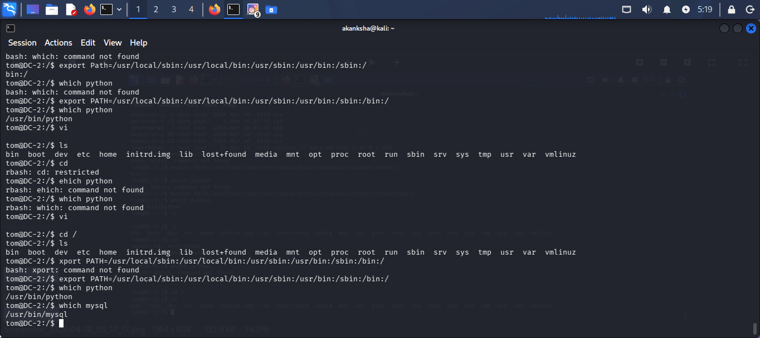  STEP 13 – Lets Enumerate and find in /var/www/html because its running Wordpress CMS  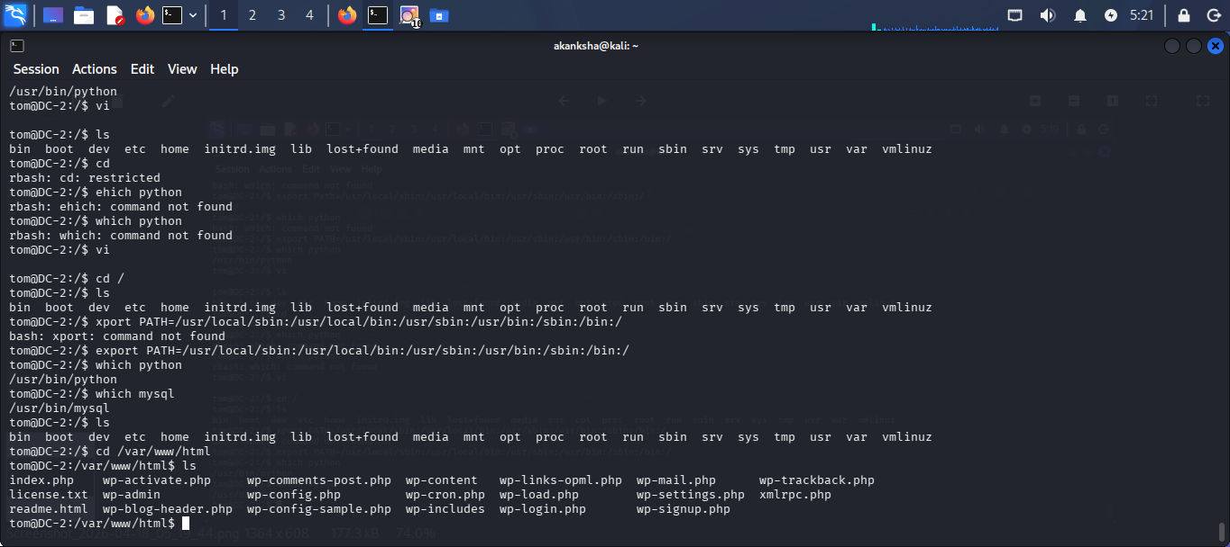  And Here we got credentials for database server (wpadmin : 4uTiLL)  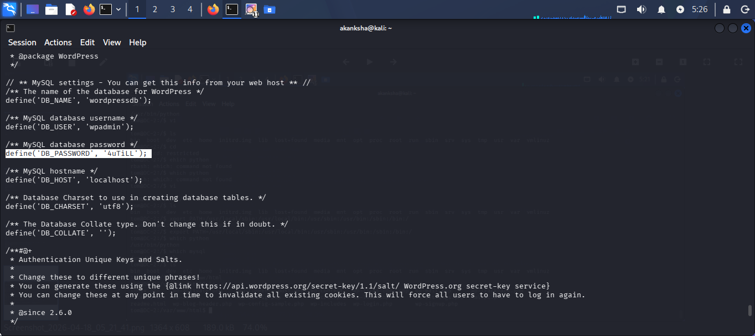  - Let’s try to authenticate.  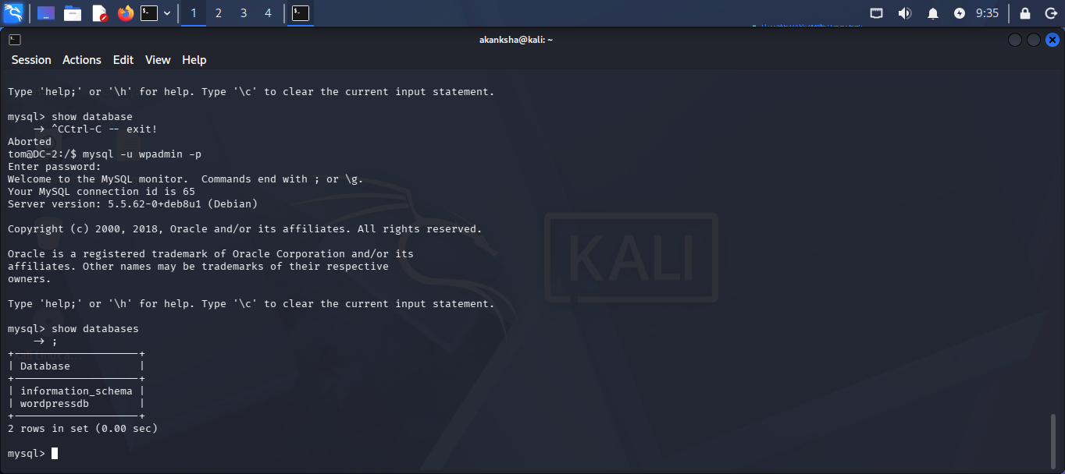  - Lets try to enumerate further here we got more hashes for users we can crack them as well but lets proceed  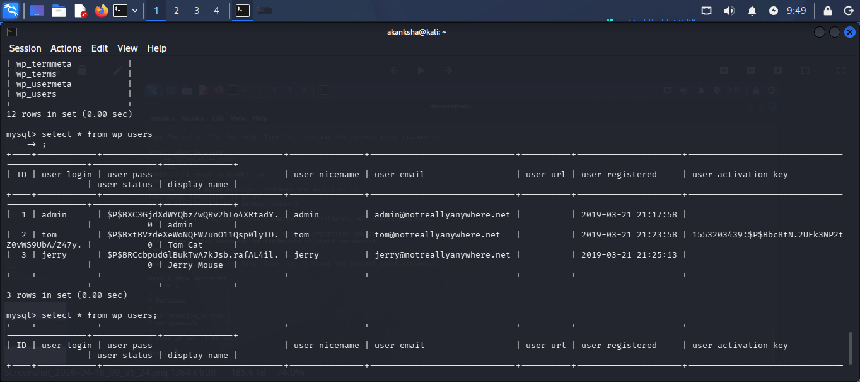  STEP 14 – Let’s try to switch user to Jerry  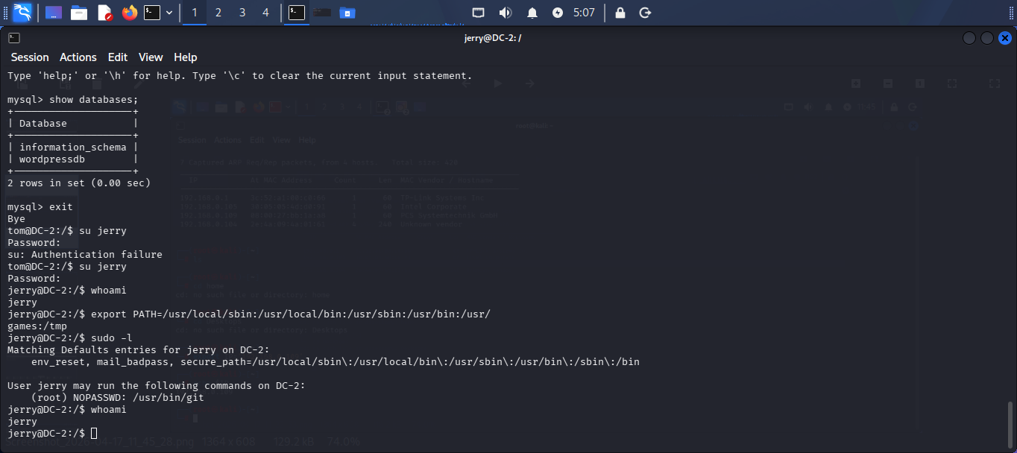  - Set Environment again so we can run commands smoothly    STEP 15 – Privilege Escalation to root user    - Jerrey is able to run git command using sudo as root without password so lets try to look in GTOFBINS  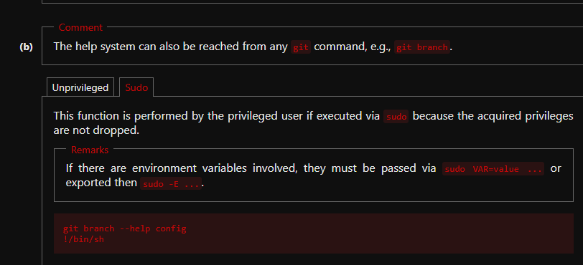  - Run Command “sudo git branch --help config” hit enter  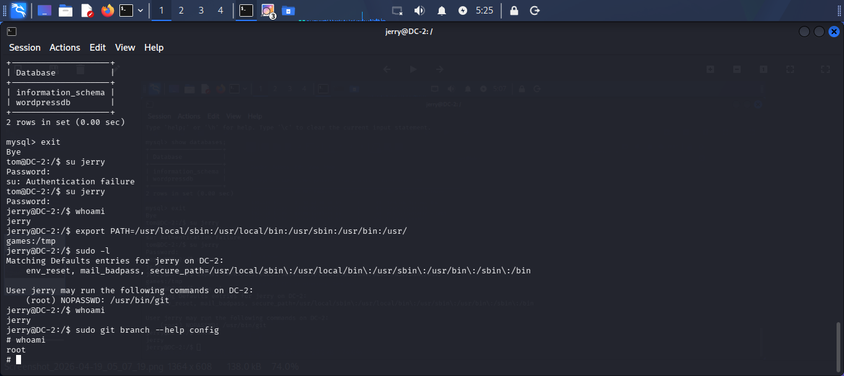  - Then insert “!/bin/dash”  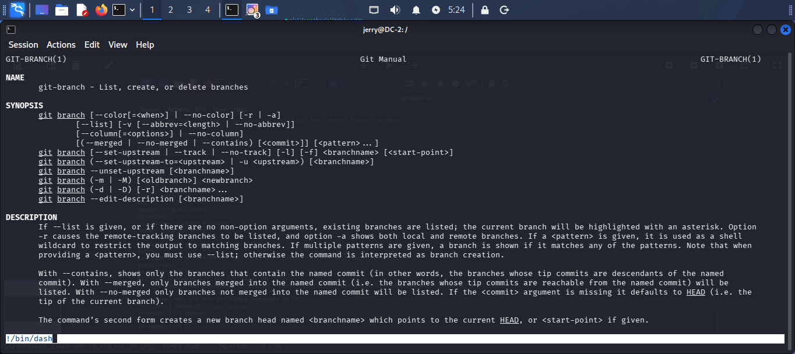  - Exit and here we got Root Access  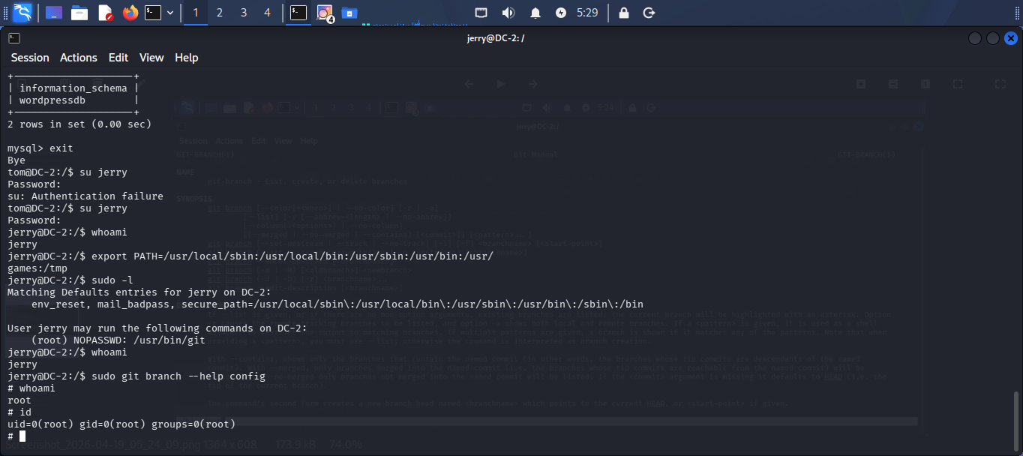  Here we got final flag in /root directory and we have solved the machine  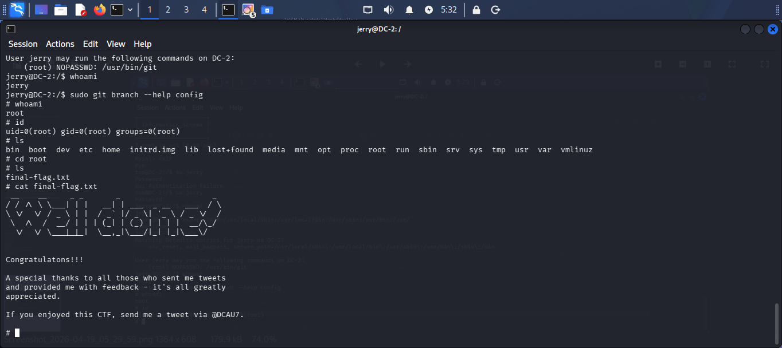  STEP 16 – Change password for users  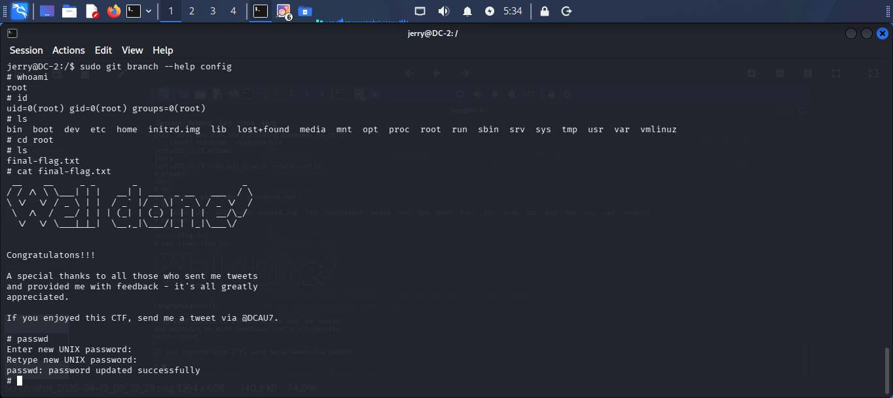
Impact | - Unauthorized access was gained through weak credentials and user enumeration.  - Sensitive information such as user credentials was exposed and exploited.  - Restricted shell protections were bypassed, allowing full command execution.  - Privilege escalation led to complete root-level control of the system.  - The compromised system could be used to access sensitive data, modify configurations, or pivot to other network systems.
Remediations | - Implement strong password policies to prevent brute-force attacks.  - Disable WordPress user enumeration and limit login attempts.  - Keep WordPress core, plugins, and themes updated to patch known vulnerabilities.  - Restrict SSH access using key-based authentication and disable password login.  - Apply proper privilege management and avoid misconfigured sudo permissions.
Reference | https://gtfobins.org/gtfobins/git/  https://www.vulnhub.com/entry/dc-2,311/

